**Some Commands:**

**Ipconfig : to show all info of a network**

**Ipconfig /all: this will give all info of all the network of our device including DNS, Mac etc**

**route print: this will the table of all network including getway ,ipv4 etc.**

**MAC Address:**

* MAC stands for Media Access Control (MAC).
* Every LAN card has a unique 48 Bits Address called MAC Address.
* Media Access Control address represented in Hexadecimal Format.
* Media Access Control address used for Layer 2 Datalink Layer communication.
* Media Access Control Address used for switching.
* MAC Addresses is 12-digit number used to identifiers the devices unequally.
* It has two Parts, OUI (Organisation Unique Identifier) and Serial Number.
* MAC Address is total 48 Bits, 24 Bits OUI and 24 Bits is company Serial Number.
* MAC Address also called Hardware, Physical, Fixed, BIA (Burn In Address),48 Bit.
* NIC, Ethernet, Data link Layer, Layer 2, Manufacturer & Adapter Card Addresses.
* Start > Run > CMD > getmac

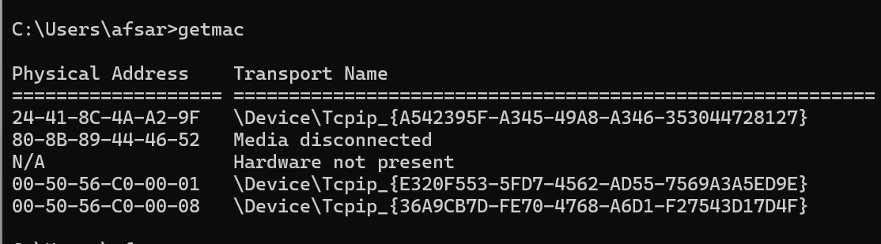

* Mac Address lookup is the website used to find the organization the mac belongs to.
* In cmd in windows getmac command is used to find the physical addres­­­ss of device.